Factors affecting the rate of chemical reaction are studied under ______________.
A. Electrochemistry
B. Chemical kinetics
C. Biochemistry
D. Stoichiometry
ANSWER: B

Chemical kinetics deals with
A. Rate of reaction
B. Mechanism of reaction
C. Order of reaction
D. All
ANSWER: D

What is studied in chemical kinetics?
A. Structure of molecules
B. Possibility of whether the reaction will occur or not
C. Reactants will transform into which product
D. The study of reaction rates of chemical and physical changes.
ANSWER: D

In which field is chemical kinetics not useful?
A. To slow down the corrosion of iron by using barrier protection.
B. In using potassium meta bisulphate to preserve food for a long time and to prevent spoiling of food.
C. To prevent spoiling of milk by keeping low temperature.
D. To know the proportion to which reactants will be converted into products.
ANSWER: D
An acid-base neutralization reaction is completed in
A. Seconds
B. Minutes
C. Milliseconds
D. Microseconds
ANSWER: D

Which unit of time is selected for fast reactions?
A. Day
B. Second
C. Year
D. Nanosecond.
ANSWER: D

Which of the following is indicated by the stoichiometry of the reaction?
A. Order of reaction
B. Mechanism of reaction
C. The number of intermediate compounds
D. The relative mole number of reactants and products.
ANSWER: D

The study of chemical kinetics is difficult for which reaction?
A. Very slow
B. Instantaneous
C. Slow
D. Very slow or instantaneous
ANSWER: D

Of which of the following factors, the rate of reaction depends on
A. The molecular mass of reactant
B. Atomic mass of reactant
C. Equivalent weight of reactant
D. Active mass of reactant.
ANSWER: D
The potential energy diagram for a reaction $R → P$ is given below. $ΔH$ of the reaction corresponds to the energy:
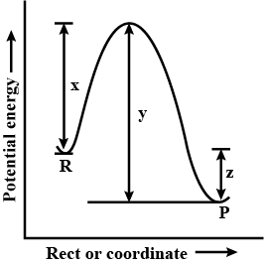
A. $X$
B. $y$
C. $z$
D. $(x=y)$
ANSWER: C
Reactants possess some minimum energy to participate in reaction. It is called _____ .
A. Nuclear energy
B. Heat of reaction
C. Activation energy
D. Potential energy
ANSWER: C
The product [X][Y] of the concentrations of X and Y is plotted against time, t, for the following second-order reaction. $X+Y→Z$. Which graph would be obtained?
A. 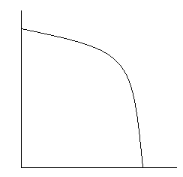
B. 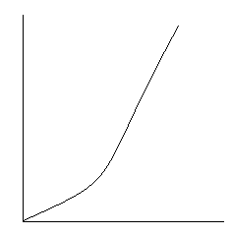
C. 
D. 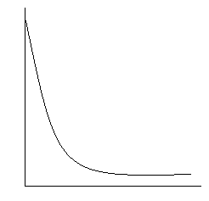
ANSWER: D
What is the SI unit of reaction rate?
A. $mol \sec^{-1}$
B. $mol m^{-3} \sec^{-1}$
C. $mol dm \sec^{-1}$
D. $mol lit^{-1}$
ANSWER: B

The reaction profile shown above is for an uncatalyzed reaction:
After the addition of the catalyst which of the following is the reaction profile for the same reaction? $2HI(g)⇋{H_{2}}_{​\left(g\right)}+I_{2​\left(g\right)}$
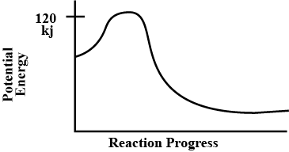
A. 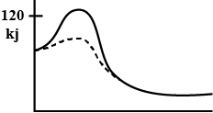
B. 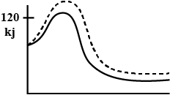
C. 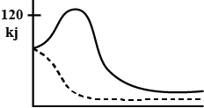
D. 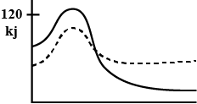
ANSWER: A
Which of the following is true about this energy diagram?
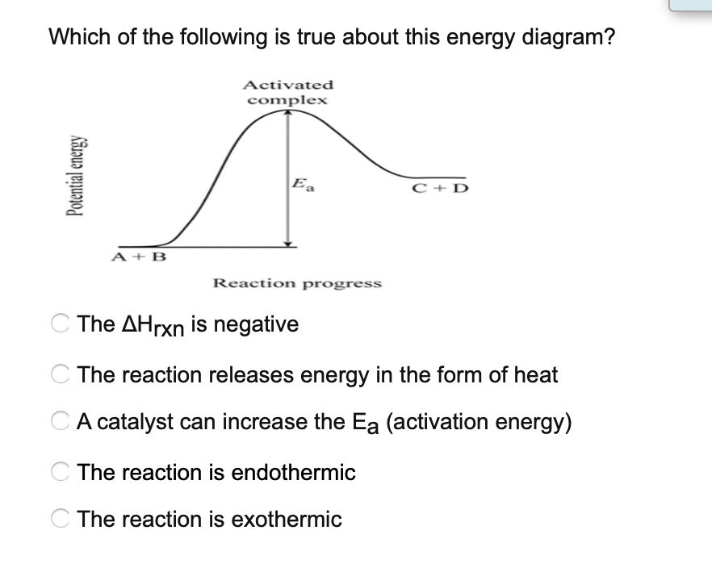
A. The $∆H$ is negative
B. The reaction releases energy in the form of heat
C. A catalyst can increase the $E_{a}$
D. The reaction is endothermic
E. The reaction is exothermic
ANSWER: E

